22 / 02 /2021

**Los colores**

1. 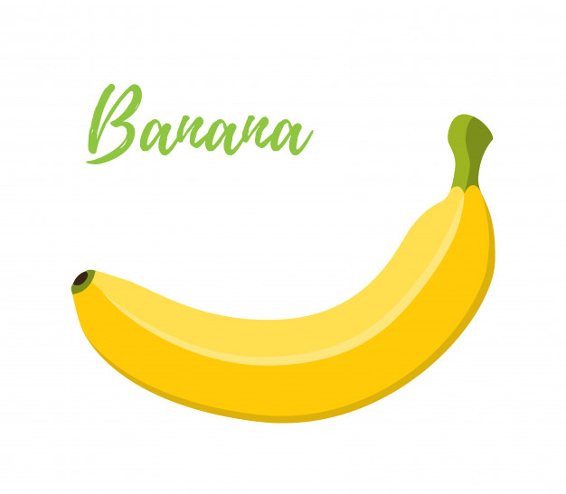**Q´an= amarillo**

**Q´an = amarillo**

**Q´an = amarillo**

**Q´an = amarillo**

**Q´an = amarillo**

1. **Kaq = Rojo**

**Kaq = Rojo**

**Kaq = Rojo**

**Kaq = Rojo**

**Kaq = Rojo**

1. 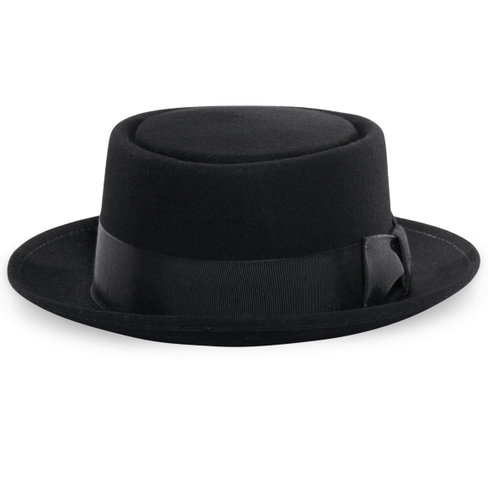**Q´eq = Negro**

**Q´eq = Negro**

**Q´eq = Negro**

**Q´eq = Negro**

**Q´eq = Negro**

1. 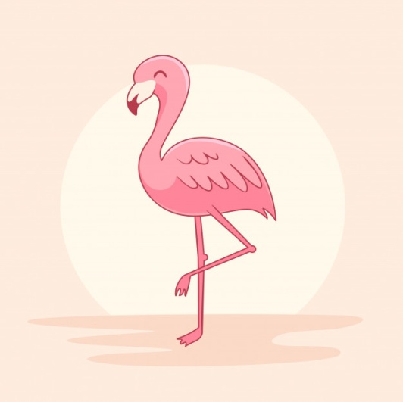**Samchak = Rosado**

**Samchak = Rosado**

**Samchak = Rosado**

**Samchak = Rosado**

**Samchak = Rosado**

1. **Raxroj = Celeste**

**Raxroj = Celeste**

**Raxroj = Celeste**

**Raxroj = Celeste**

**Raxroj = Celeste**

1. 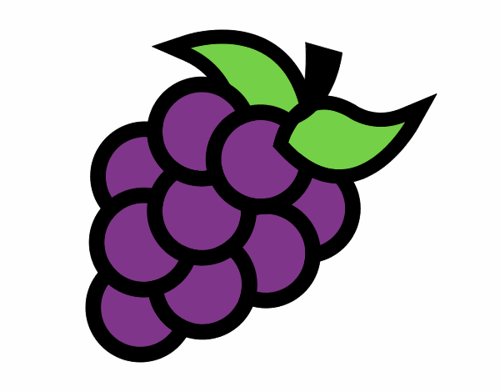**Tuq´ = Morado**

**Tuq´ = Morado**

**Tuq´ = Morado**

**Tuq´ = Morado**

**Tuq´ = Morado**

1. 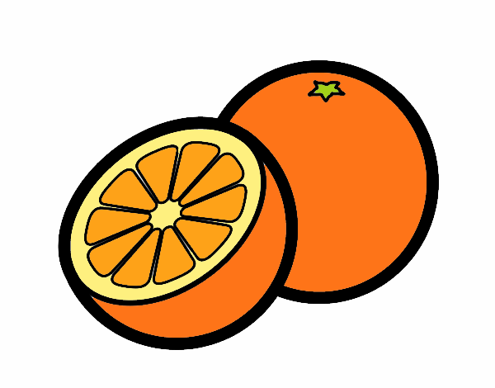**Saq = Anaranjado**

**Saq = Anaranjado**

**Saq = Anaranjado**

**Saq = Anaranjado**

**Saq = Anaranjado**

1. 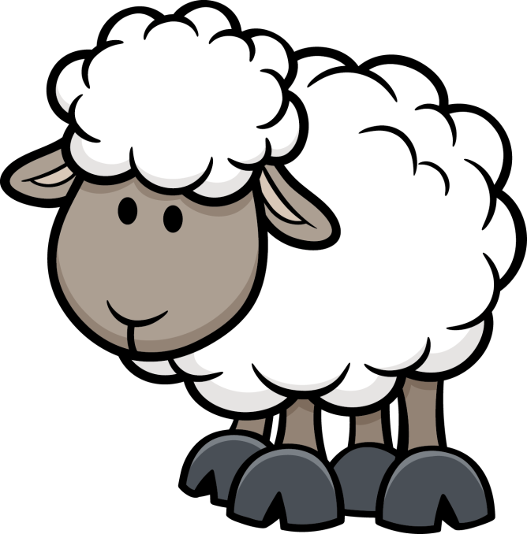**Kaqkaj = Blanco**

**Kaqkaj = Blanco**

**Kaqkaj = Blanco**

**Kaqkaj = Blanco**

**Kaqkaj = Blanco**

1. 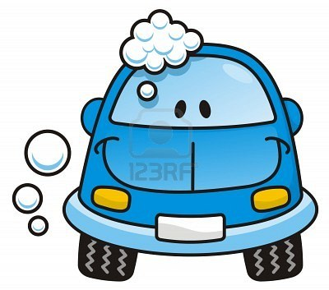**Xar = Azul**

**Xar = Azul**

**Xar = Azul**

**Xar= Azul**

**Xar = Azul**

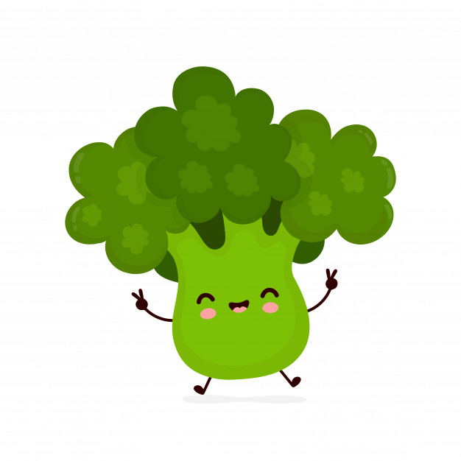

1. **Rax = Verde**

**Rax = Verde**

**Rax = Verde**

**Rax = Verde**

**Rax = Verde**